**1. Create Two Storage Accounts and Create a Container Inside Them**

**Step 1: Create Two Storage Accounts**

1. **Log in** to the Azure portal.

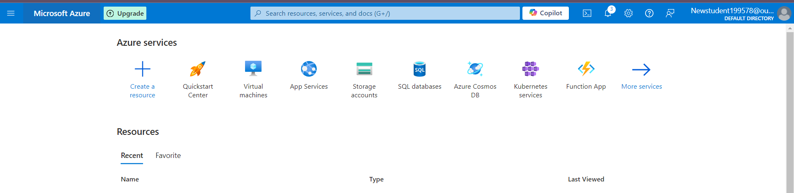

1. In the search bar, type **Storage accounts** and click on **Storage accounts** under services.

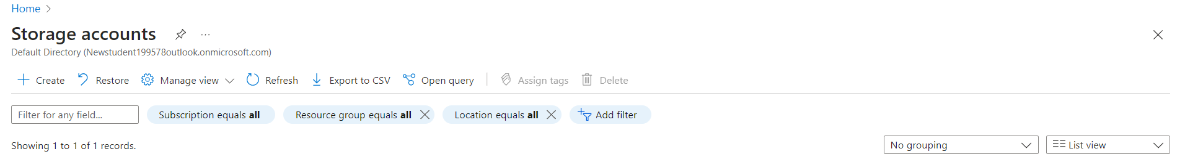

1. Click **Create**.
2. Fill in the necessary details for the first storage account:
   * **Subscription**: Choose your subscription.
   * **Resource Group**: Select an existing one or create a new one.
   * **Storage account name**: Enter a unique name for the first storage account (**shahidteam1**).
   * **Region**: Choose a preferred region.
   * **Performance**: Choose **Standard**.
   * **Replication**: Choose the replication type LRS.
   * Click **Review + Create** and then **Create**.
3. Repeat the steps to create the **second storage account** (**shahidteam2**).

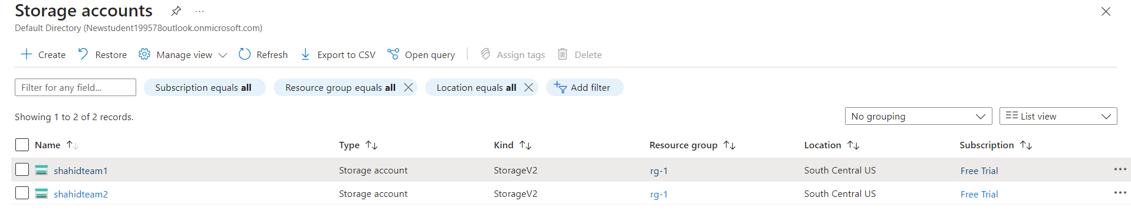

**Step 2: Create a Container Inside Each Storage Account**

1. Go to **Storage accounts** and click on the first storage account (**shahidteam1**).
2. In the left-hand menu, under **Data storage**, click **Containers**.
3. Click **+ Container** at the top, provide a name for the container (**shahidteam1container**), and select **Private** for public access.
4. Click **Create**.

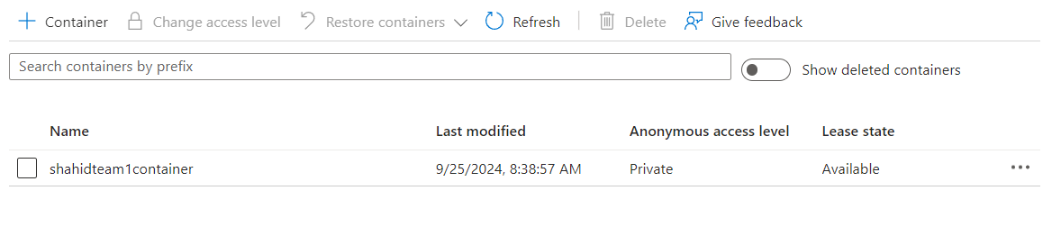

1. Repeat these steps for the second storage account (**shahidteam2**) and create another container (**shahidteam2container**).

**2. Upload Some Data to the First Blob Service**

1. Go to the first storage account (**shahidteam1**).
2. Under **Data storage**, click on **Containers**, and select **shahidteam1container**.
3. Click on **Upload** and select the files you want to upload to the Blob storage.
4. Click **Upload** to complete the process.

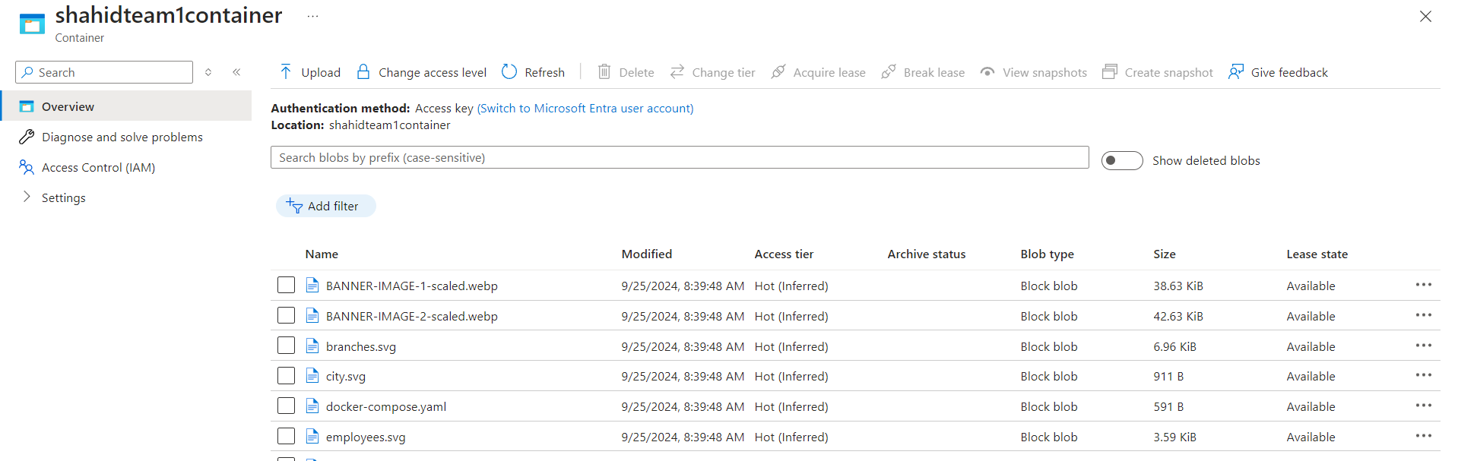

**2. Use AzCopy Utility to Copy Data from One Storage Container to Another**

1. In the **Azure Portal**, open **Cloud Shell** (via the top bar of the portal).
   * Select **Bash** or **PowerShell**.
   * This comes pre-configured with **AzCopy**.
2. Copy the data from container1 to container2 using the AzCopy command:

**azcopy copy "https://shahidteam1.blob.core.windows.net/shahidteam1container?sv=2024-09-25&ss=b&srt=sco&sp=rl&se=2024-09-26T03:56:15Z&st=2024-09-24T03:56:15Z&spr=https&sig=<token>" "https://shahidteam2.blob.core.windows.net/shahidteam2container?sv=2024-09-25&ss=b&srt=sco&sp=rl&se=2024-09-26T03:56:15Z&st=2024-09-24T03:56:15Z&spr=https&sig=<token>" --recursive**

